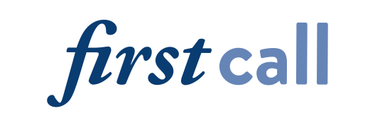

2024 Annual Community Gratitude Breakfast
March 21, 2024

CALL FOR NOMINATIONS

First Call’s Annual Community Gratitude Breakfast celebrates those who work to reduce the impact of alcohol, drugs and addiction by recognizing champions who:
- Help create safe and healthy communities
- Support individuals and families seeking recovery
- Volunteer their time; donate their dollars and/or advocate for public policy changes
Please send your nomination to recognize an individual in the following categories:
- Lifetime Achievement: A person who has dedicated their longstanding career to work in the substance use disorder treatment, recovery or prevention fields.
- Professional of the Year: A person who is committed to providing quality direct services in the substance use disorder treatment or prevention fields.
- Recovery Champion: A person who has reduced stigma and improved access to recovery through peer support, advocacy or public policy change.
- Youth of the Year: A youth advocate working to prevent substance use and reduce substance misuse in the community.

Nominations can also be submitted online at firstcallkc.org/gratitudenominations

Nomination – Due by January 5, 2024
Nominee Information
Nominee Name | Title | Agency or community affiliation
Email | Telephone
Recognition Category: □ Lifetime Achievement □ Professional of the Year □ Recovery Champion □ Youth of the Year
Your Information
Your Name | Title | Agency or community affiliation
Email | Telephone

Please describe below why this nominee should receive recognition. (Supporting material may be attached.)
Please tell us how you know the nominee.

Return completed nomination forms by January 5, 2024
Sarah Link Ferguson, Development & Events Manager
Email: sferguson@firstcallkc.org · Mail: First Call, 9091 State Line Road, Kansas City, MO 64114

Family members of First Call employees are not eligible for consideration.

